HOTEL REVENUE ANALYSIS
MODULE 3
1. Objective
In this module, our goal is to merge tables like TblRates, Tbl_Bookings in power query editor and add columns like SourceType, GuestType, RoomRate, NumOfBookings, CustomerCluster in the Booking table. We also have to create Tbl_Guests and add columns like FrequencyScore, SpendScore, RecencyScore which will be helpful in guest analysis.
2. Tables
2.1 Creation of TblRates and Tbl_Bookings:
- Copy the columns RoomTypeID and Price from RoomType table into another sheet. This is TblRates table.
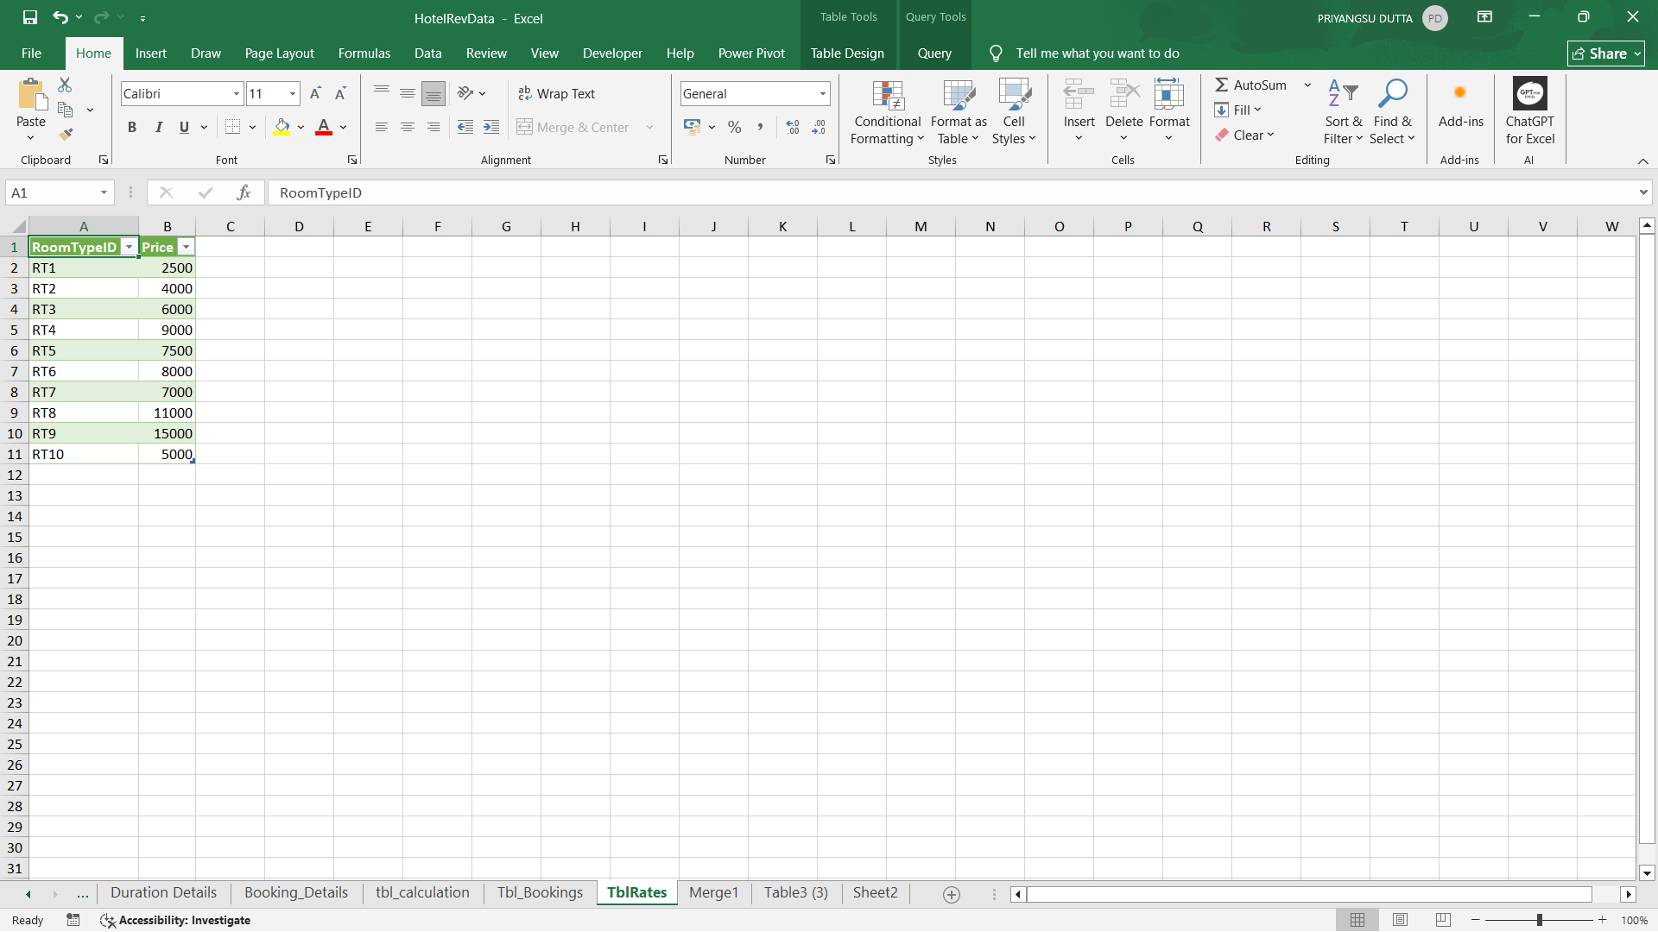
- Copy the column of Booking table from BookingID to Revenue in another sheet and name this table Tbl_Bookings. Then merge this table with TblRates using RoomTypeID. Name the column DayRevenue.
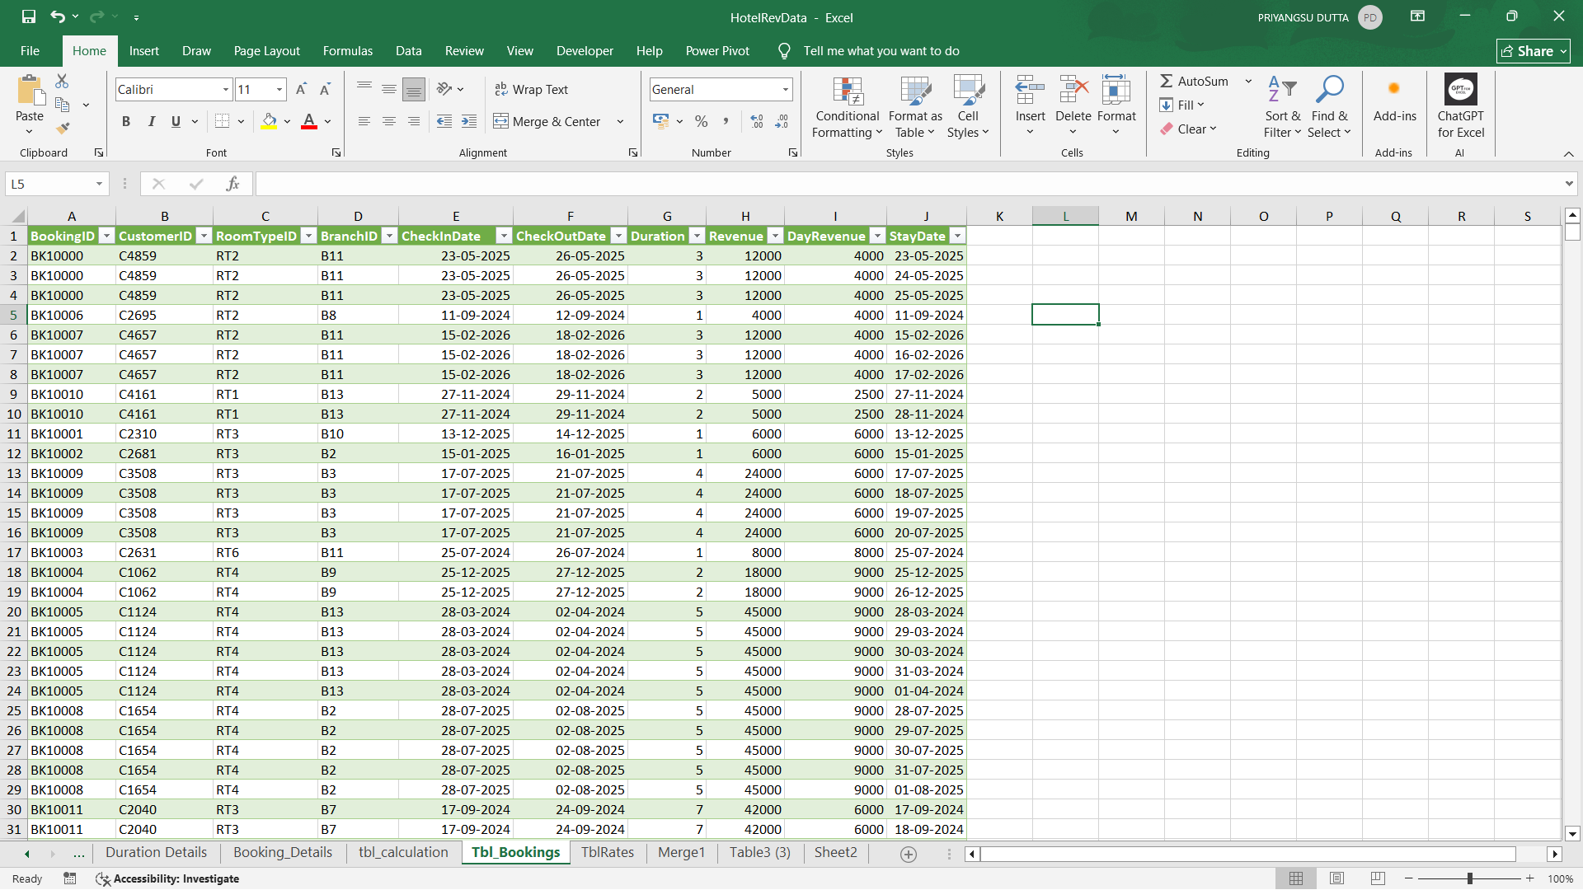
2.2 Load the extra tables in Power BI:
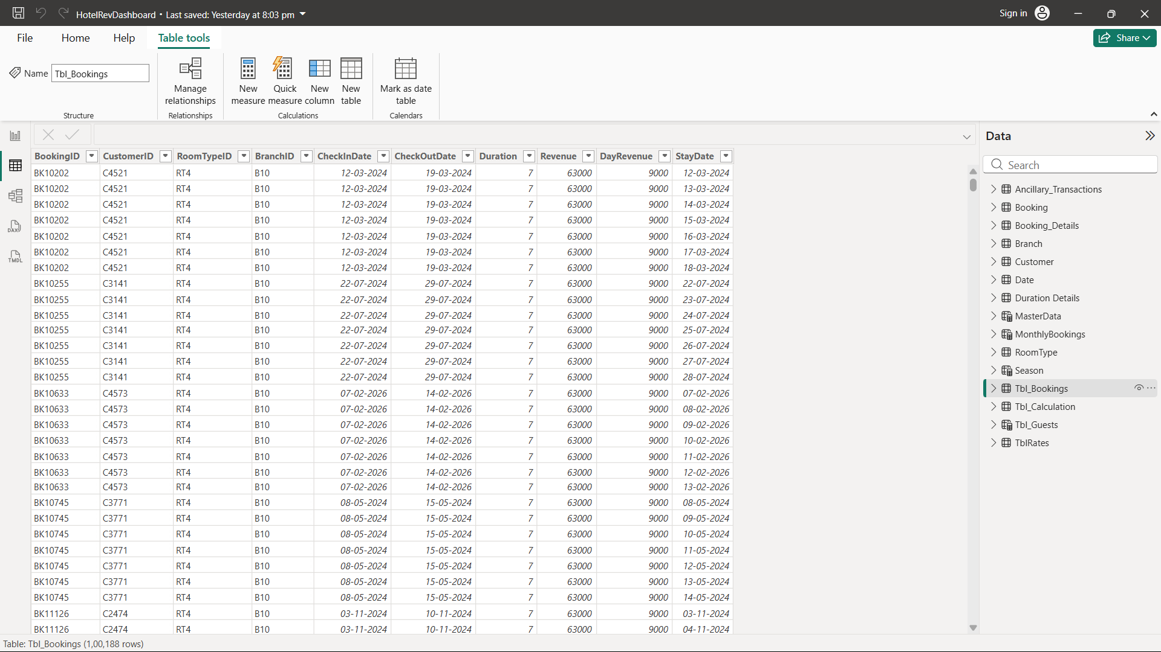
2.3 Creating new columns in Booking Table:
- Using New column in Power BI create the following columns:
SourceType =
SWITCH(
'Bookings'[BookingChannel],
"Call Center", "Direct",
"Mobile App", "Direct",
"Website", "Direct",
"Travel Agent", "OTA",
"Other"
)
GuestType =
SWITCH(TRUE(),
[Purpose] = "Business" || [BookingChannel] = "Corporate", "Business",
[Purpose] = "Vacation" && [StayType] = "Extended Stay", "Family",
[Purpose] = "Holiday" && [StayType] = "Extended Stay", "Family",
[Purpose] = "Conference" || [StayType] = "Extended Stay","Corporate",
"Solo"
)
RoomRate =
RELATED(Room[Price])
NumOfBookings =
CALCULATE(
COUNT(Bookings[BookingID]),
ALLEXCEPT(Bookings, Bookings[CustomerID])
)
CustomerCluster =
SWITCH(TRUE(),
[NumOfBookings] = 1 && [Revenue] < 5000, "First-Timer",
[NumOfBookings] >= 3 && [Revenue] < 15000, "Loyal Guest",
[Revenue] >= 15000, "High Spender",
"Other"
)

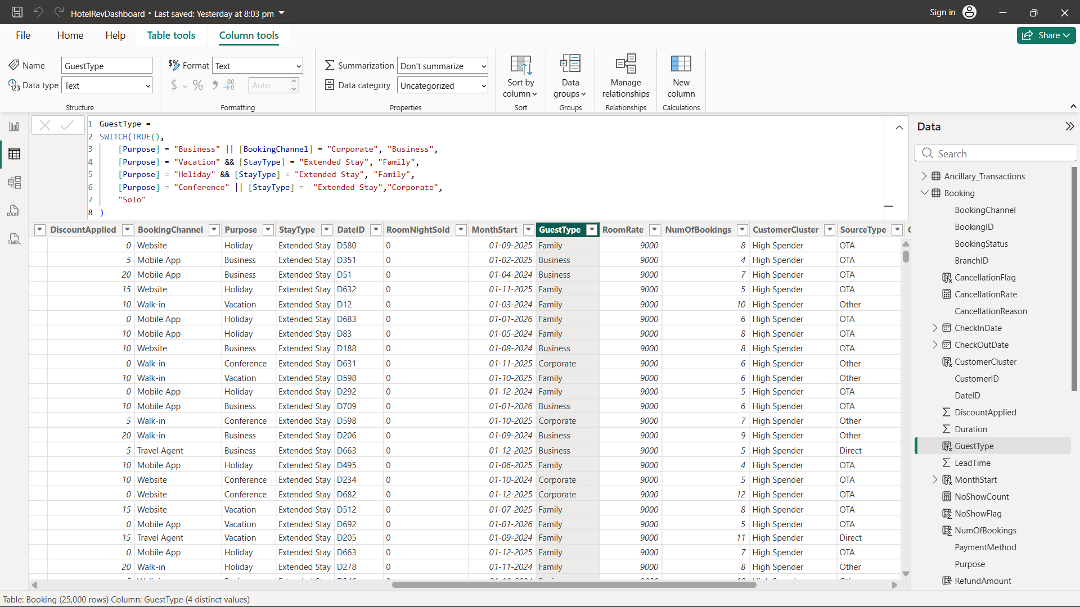
2.3 Creating Tbl_Guest Table and add new columns:
- Create a new table in Power BI:
Tbl_Guests =
SUMMARIZE(
'Tbl_Bookings',
'Tbl_Bookings'[CustomerID],
"FirstStay", MIN('Tbl_Bookings'[CheckInDate]),
"LastStay", MAX('Tbl_Bookings'[CheckOutDate])
)

- Create the following columns using New column in Power BI:
FrequencyScore =
CALCULATE(
COUNTROWS('Tbl_Bookings'),
FILTER('Tbl_Bookings', 'Tbl_Bookings'[CustomerID] = 'Tbl_Guests'[CustomerID])
)
SpendScore =
CALCULATE(
SUM('Tbl_Bookings'[DayRevenue]),
FILTER('Tbl_Bookings', 'Tbl_Bookings'[CustomerID] = 'Tbl_Guests'[CustomerID])
)
RecencyScore =
DATEDIFF(
CALCULATE(
MAX('Tbl_Bookings'[CheckOutDate]),
FILTER('Tbl_Bookings', 'Tbl_Bookings'[CustomerID] = 'Tbl_Guests'[CustomerID])
),
TODAY(),
DAY
)
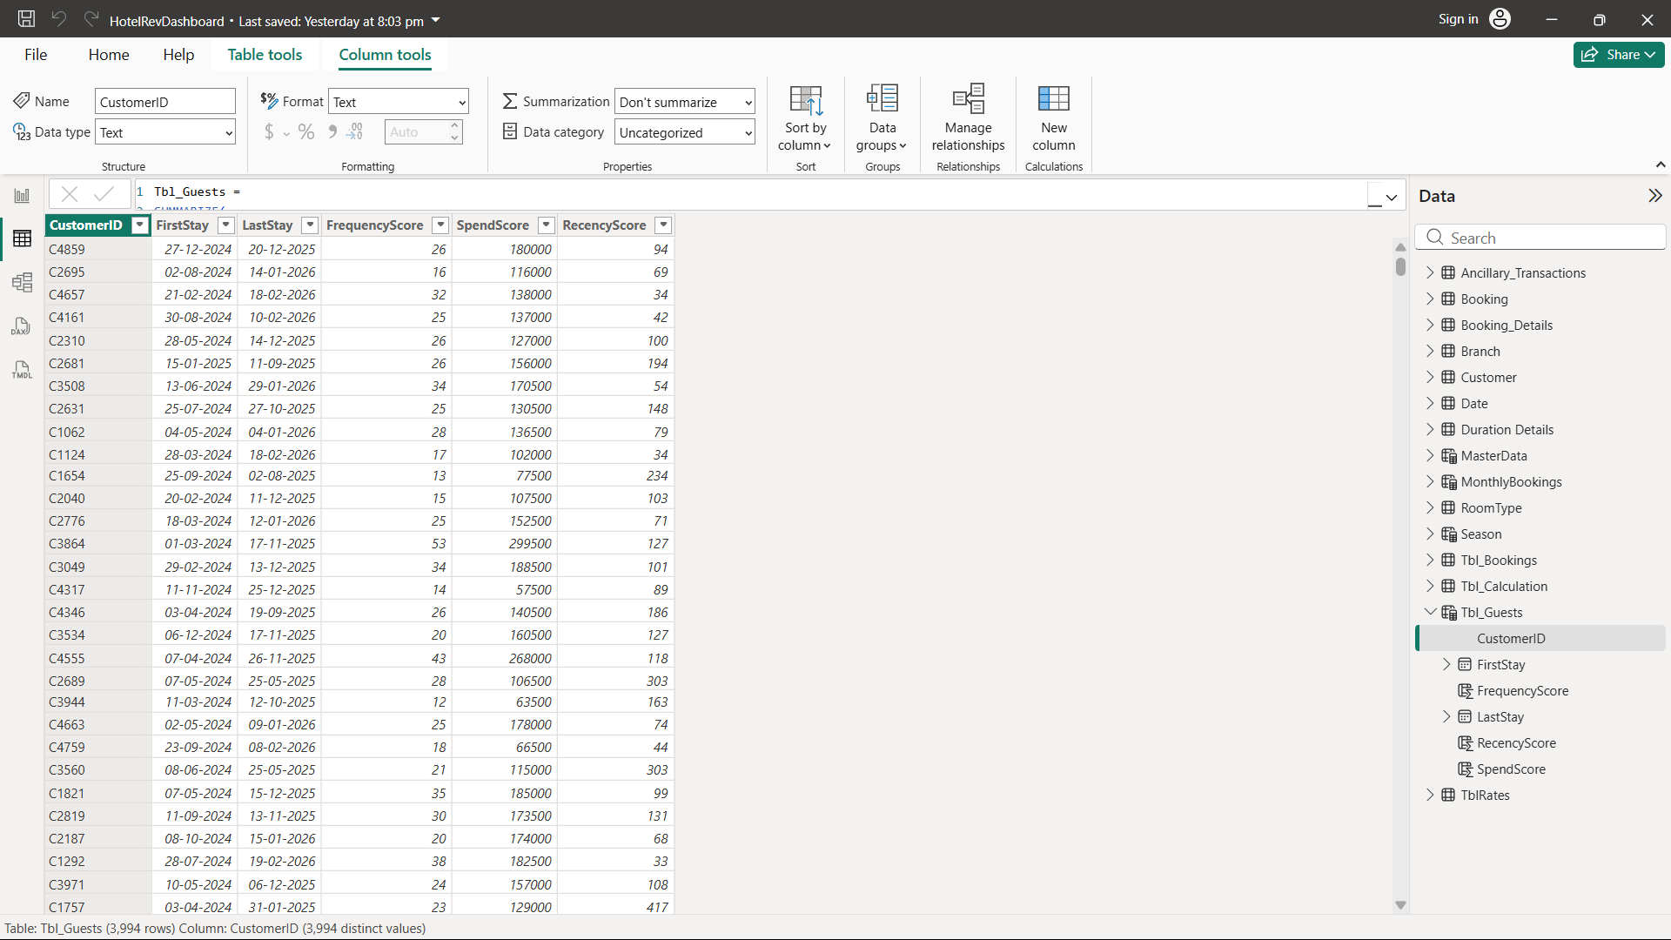

3. Visuals
3.1 Guest Analysis:
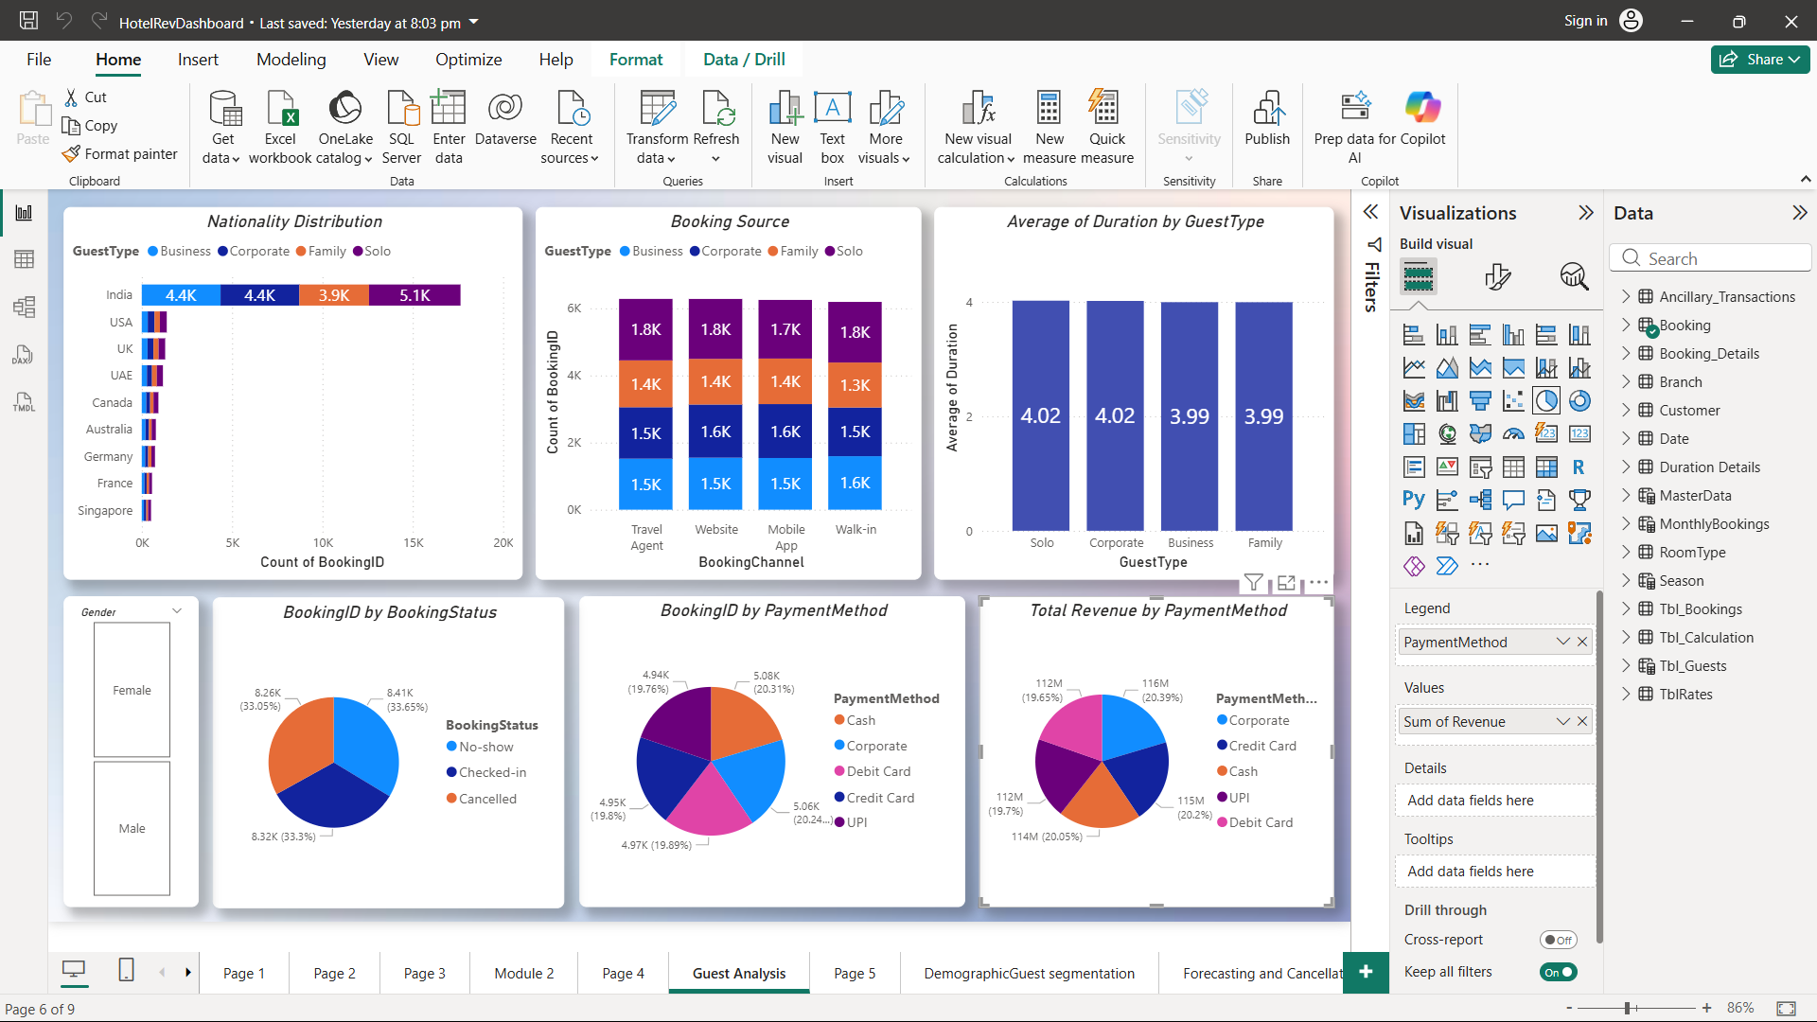
3.2 Scatter Chart (Based on sum of SpendScore, sum of FrequencyScore and CustomerID by RecencyScore and CustomerCluster):
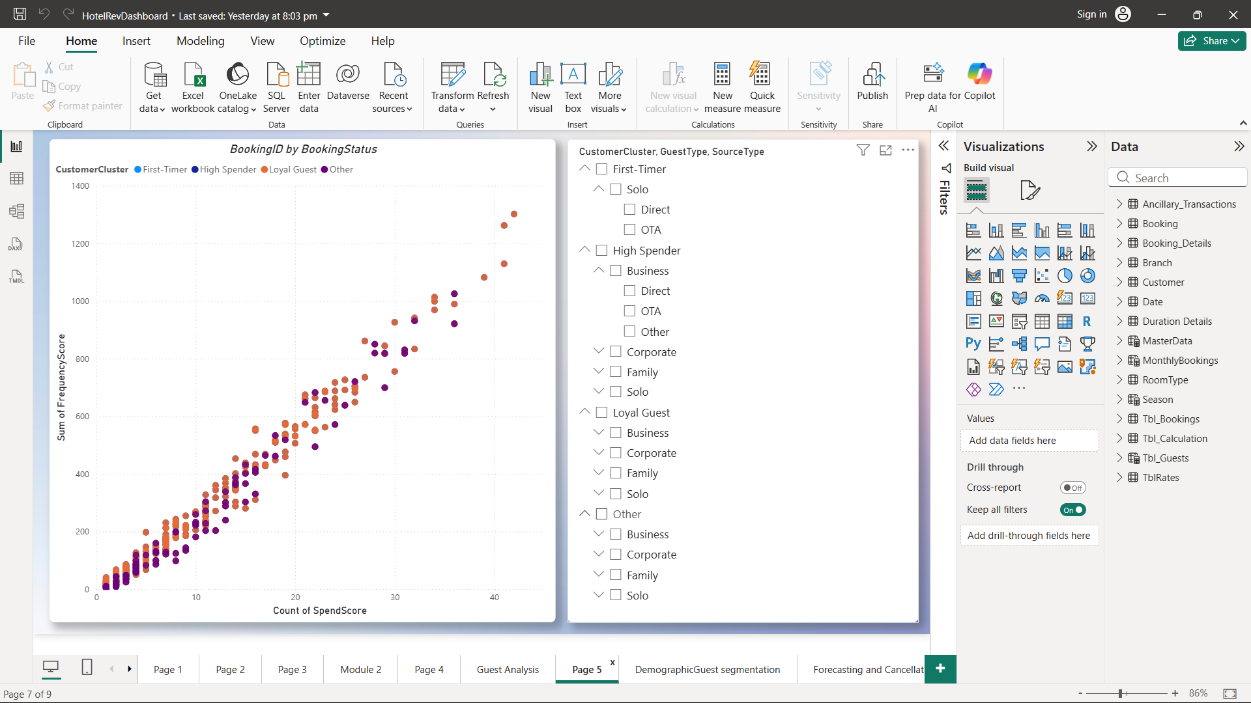
3.3 Demographic Guest Segmentation (Based on Nationality , CustomerCluster, SourceType, GuestType):
